

Foundations of Programming

Assignment No.: 16
PROBLEM STATEMENT: To accept a list of N integers and partition the list into two sublists containing even and odd numbers.

OBJECTIVE:

- To understand how to work with arrays in C.
- To learn how to separate numbers based on conditions.
- To practice the use of loops and conditional statements.
- To display two different lists for even and odd numbers.

THEORY:
In C programming, arrays are used to store multiple values of the same data type. By using loops and conditional statements, it is possible to examine each element in the array and classify it based on certain conditions. In this program, the user enters N integers which are stored in an array. Each number is then checked using the modulus operator (%). If a number is divisible by 2, it is categorized as an even number; otherwise, it is an odd number. The program then displays two separate lists: one for even numbers and another for odd numbers.

ALGO:
1. Start

2. Declare Variables
- n → number of elements
- Array A[n] → to store input integers
- Arrays:
  - even[n]
  - odd[n]
- Counters:
  - e = 0 (even count)
  - o = 0 (odd count)

3. Input
- Read n
- Input n integers into array A

4. Partition Logic
- For i = 0 to n-1, repeat:
  - If A[i] % 2 == 0
→ even[e] = A[i]
→ e++
  - Else
→ odd[o] = A[i]
→ o++

5. Output Even List
- Print "Even numbers:"
- For i = 0 to e-1, display even[i]

6. Output Odd List
- Print "Odd numbers:"
- For i = 0 to o-1, display odd[i]

7. Stop

FLOWCHART:
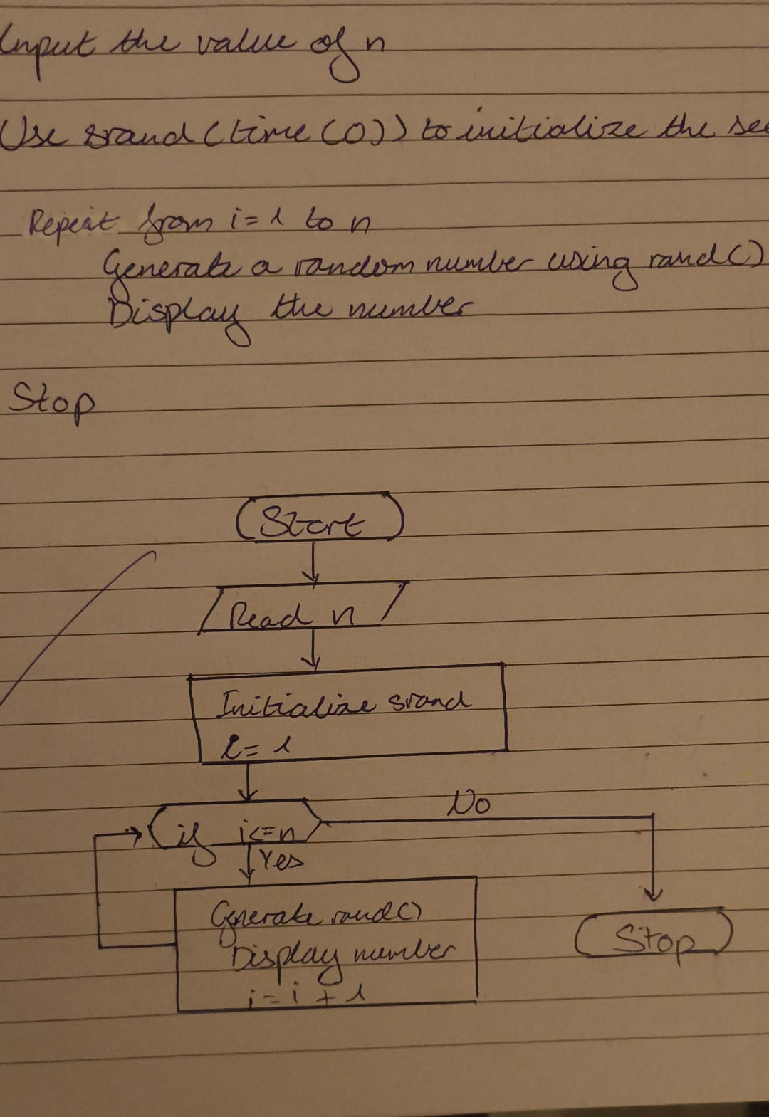

PLATFORM: Linux
CODE:
#include <stdio.h>

int main() {
int array[10], E[10], o[10];
int ec = 0, oc = 0;

for (int i = 0; i < 10; i++) {
printf("Enter the value for element %d: ", i);
scanf("%d", &array[i]);
}

printf("The elements of the array are: ");
for (int i = 0; i < 10; i++) {
printf("%d ", array[i]);
}

for (int i = 0; i < 10; i++) {
if (array[i] % 2 == 0)
E[ec++] = array[i];
else
o[oc++] = array[i];
}

printf("\nEven elements: ");
for (int i = 0; i < ec; i++)
printf("%d ", E[i]);

printf("\nOdd elements: ");
for (int i = 0; i < oc; i++)
printf("%d ", o[i]);

printf("\n");
return 0;
}

INPUT: Number of integers (N) and the list of integers.

OUTPUT: Displays two lists: Even numbers and Odd numbers.
SAMPLE INPUT:
Enter number of elements: 5
Enter integers: 10 7 4 9 12

SAMPLE OUTPUT:
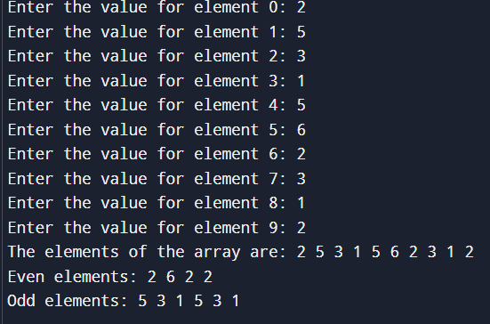
CONCLUSION: Thus, the C program successfully accepts a list of integers and partitions them into two separate lists of even and odd numbers.

FAQs:
- Which operator is used to check even and odd numbers in C?
- Why are arrays used in this program?
- How does the modulus (%) operator help in separating even and odd numbers?

